To Address security for my term project I ran a ZAP proxy attack and got the following results

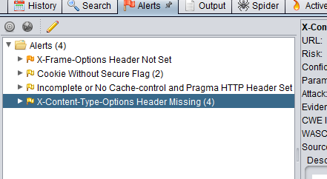

I then implanted the following code to address these

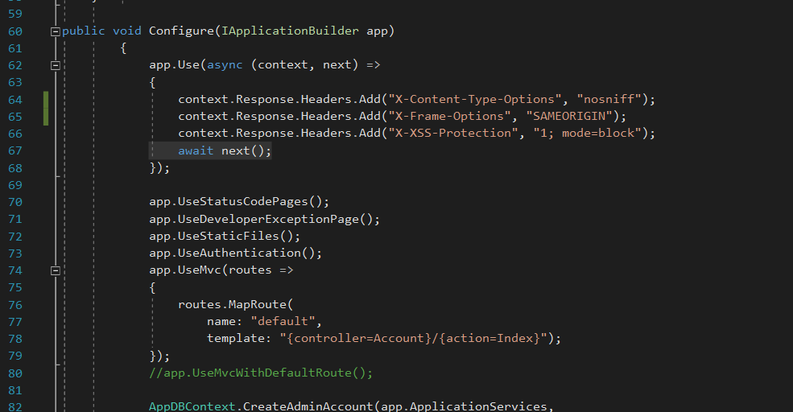

Interestingly the x-content-type-options error persisted in multiple different pages making me think that while I fixed it for the majority of the site I did not fix it in all instances. More investigation is required.

The Jmeter test provided the following and can be found in the term project folder

